
Clinical Scheduling for Windows
(BSDX)
Installation Guide and Launch Notes
Version 1.0
June 2013

Preface
This manual provides information regarding only the release and installation of the Clinical Scheduling for Windows 1.0 package.

Security
The BSDX uses security keys to limit user’s ability to change system set-up parameters and patient information. In other words, not all BSDX options are available to all users. Contact your site administrator to determine or change your security keys.

Table of Contents
Preface i
Security i
1.0 Release Notes 1
2.0 Installation Notes 2
3.0 Installation Instructions 3
3.1 Standard Client Deployment 3
4.0 Launch Instructions 7
4.1 Use Cases 7

Release Notes
This release consists of Version 1.0 of Medsphere Clinical Scheduling for Windows (BSDX).

Installation Notes
- Current Version: 1.0
Warning: Read entire notes file prior to attempting any installation.

Installation Instructions

Standard Client Deployment
To install Medsphere Clinical Scheduling ver 1.0 the following requirements need to be met:
- Medsphere Clinical Scheduling Client
- Sikuli Test Cases
- VA FileMan v22
- Kernel v8
- PIMS v5.3 and subsequent patches 1001 through 1003
- BMX v2

Of the 6 requirements, two were already established:
- VA FileMan v22
- Kernel v8

Medsphere Clinical Scheduling Client
To satisfy the install for the CA server, select the Scheduling zip and extract the files to the folder:
C:\ClinicalSchedulerCA
To satisfy the install for the AL server, select the Scheduling zip and extract the files to the folder:
C:\ClinicalSchedulerAL
To satisfy the install for the GA server, select the Scheduling zip and extract the files to the folder:
C:\ClinicalSchedulerGA
Sikuli Test Cases
To satisfy the install for the Use Cases, select the SikuliUsesCases zip file and extract the files to the folder:
C:\sikuli_scripts
BMX v2
To satisfy the BMX v2 package requirement, an install was done, using file: bmx_0200.k, BMX dotNET BROKER UTILITIES 2.0

PIMS v5.3 and subsequent patches 1001 through 1003
To satisfy the PIMS v5.3 and subsequent patches 1001 through 1003 requirement, it was first necessary to establish PIMS v5.3. PIMS v5.3 package has the following requirements:

- AUT V98.1 and subsequent patches 1 through 13, used the following files:
aut_9810.rsa, to establish the package and uses the prior to KIDS process of D ^AUTINIT
The following are KIDS installations for patches 1-13:
aut_9810.01k
aut_9810.02k
aut_9810.03k
aut_9810.04k
aut_9810.05k
aut_9810.06k
aut_9810.07k
aut_9810.08k
aut_9810.09k
aut_9810.10k
aut_9810.11k
aut_9810.12k
aut_9810.13k

- AUPN v99.1 and subsequent patches 1 through 13, used the following files:
aupn932.r, to establish the package and uses the prior to KIDS process of D ^AUPNINIT
aupn9910.tar, to update to version 99.1 and uses the prior to KIDS process of D ^AUP1INIT
The following are KIDS installations for patches 1-13:
aupn9910.01k
aupn9910.02k
aupn9910.03k
aupn9910.04k
aupn9910.05k
aupn9910.06k
aupn9910.07k
aupn9910.08k
aupn9910.09k
aupn9910.10k
aupn9910.11k
aupn9910.12k
aupn9910.13k

- XB v3.0 and subsequent patches 1 through 9, used the following files:
XB.RSA, to establish the package and uses the prior to KIDS process of D ^XBINIT
xb__0300.01p, is a routine restore and was how patches were installed prior to KIDS
xb__0300.02p, is a routine restore and was how patches were installed prior to KIDS
xb__0300.03p, is a routine restore and was how patches were installed prior to KIDS
xb__0300.04p, is a routine restore and was how patches were installed prior to KIDS
xb__0300.05p, is a routine restore and was how patches were installed prior to KIDS
xb__0300.06p, is a routine restore and was how patches were installed prior to KIDS
The following are KIDS installations for patches 7-9:
xb__0300.07k
xb__0300.08k
xb__0300.09k

- AG v7.0 and subsequent patch 1, used the following files:
All are KIDS files
ag__0700.tar
ag__0700.01k

- AVA v93.2 and subsequent patches 1-18, used the following technique to establish the package and patch installation:
Because AVA v93.2 was distributed by IHS as part of Kernel v7.0 and since even thinking about installing Kernel v7.0 on a Kernel v8.0 is not possible. If one attempted to do this install all packages would not function properly. Therefore the following was done to establish the package registration:

CONTEST>D Q^DI

MSC FileMan 22.1041

Select OPTION: ENTER OR EDIT FILE ENTRIES

Input to what File: PACKAGE// (144 entries)
EDIT WHICH FIELD: ALL// VERSION (multiple)
EDIT WHICH VERSION SUB-FIELD: ALL//
THEN EDIT FIELD: CURRENT VERSION
THEN EDIT FIELD:

Select PACKAGE NAME: IHS VA SUPPORT FILES
Are you adding 'IHS VA SUPPORT FILES' as a new PACKAGE (the 145TH)? No// Y
(Yes)
PACKAGE PREFIX: AVA
Select VERSION: 93.2
Are you adding '93.2' as a new VERSION (the 1ST for this PACKAGE)? No// Y
(Yes)
VERSION DATE DISTRIBUTED: T (JUN 02, 2013)
DATE DISTRIBUTED: JUN 2,2013//
DATE INSTALLED AT THIS SITE: ^
CURRENT VERSION: 93.2

Then the following KIDS files were installed:
ava_9320.12k
ava_9320.13ek
ava_9320.14ek
ava_9320.15k
ava_9320.16k
ava_9320.17k
ava_9320.18k

- PIMS v5.3 Installation, used the following files:
pims0530.k, this KIDS build establishes the PIMS v5.3 package
These KIDS files are patches 1001 through 1003
pims0530.01k
pims0530.1002k
pims0530.1003k

- BSDX 4.0 installation, used the following files:
bsdx0400.t1k

Launch Instructions

Use Cases
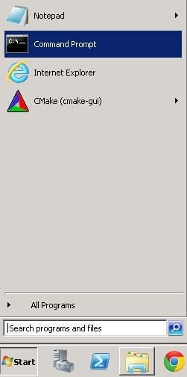
- Select the Start button
- Select the Command prompt
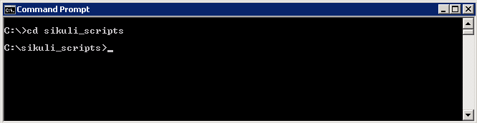
At the command prompt CD to sikuli_scripts
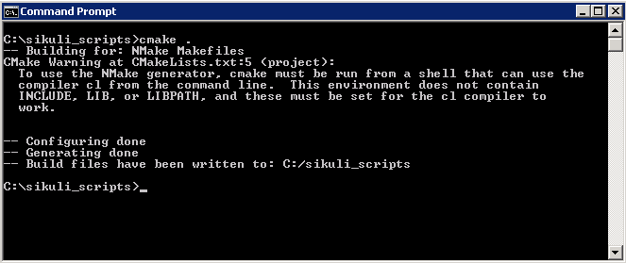
In the sikuli_scripts folder type “cmake .” to make the files to launch the use cases. The ‘.’ is very important.
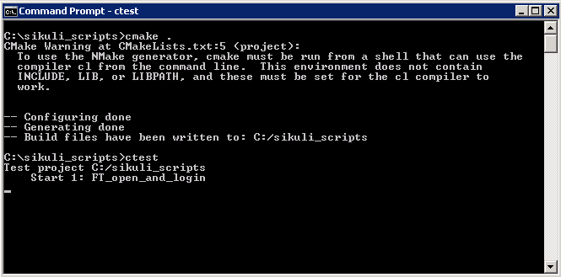
To run the scripts type ctest at the command line.

